s3. Write a javascript function that prints the reverse of a number. Example: if the

number is 149, then output should be 941.

Ans:

let reverse_num = 0;

let number_value = 149;

let result;

while(number_value != 0){

result = number_value % 10;

reverse_num = reverse_num * 10 + result;

number_value = Math.floor(number_value/10);s

}

console.log("The Reversed number is : "+reverse_num);

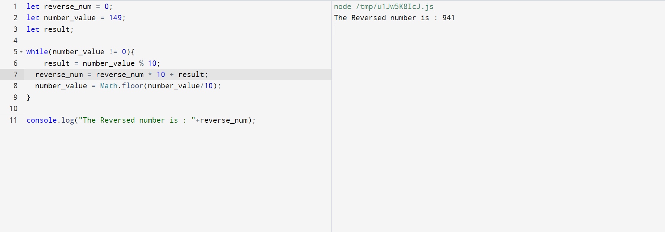

4. Describe the best project you have worked on, including links if any.

The Hotel Management System is a web-based tool that allows the hotel manager to oversee hotel operations from anywhere in the world. This system is incredibly adaptable and convenient due to its interactive GUI and capacity to manage hotel bookings and rooms. The hotel manager is extremely busy and does not have time to sit and manually supervise all of the activities. This program allows him the ability to operate the entire system from a single online interface, giving him more power and flexibility. Room booking and other hotel management services are included in the hotel management project. The management can use the system to advertise available rooms. Customers may see and reserve rooms on the internet. As a result, the technology is handy for both consumers and management to control hotel activities on the go.

Project Link: <https://github.com/sandeepreddy123321/Hotel-Webapplication.git>

5. If you are to start a software company, name 2 people from your batch whom you will choose as your partner and why?

Ans:

I would pick Pavan and Charan from my group when we were starting a software company because they have a unique way of thinking about problems. Charan used to consider how the problem came about and make sure the issue wouldn't crop up again in the future whereas Pavan used to consider several approaches to solving the same problem. If a firm wants to grow and generate more profit, someone has to think outside of the box. If one does not, then the other may yield the greatest results, and finally, we have an optimum answer that provides an instant solution for a difficult problem.